Unix Commands:––
- top: this command is used to know the cpu utilization in Linux .
Ans:
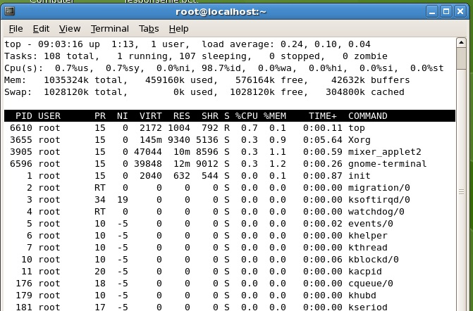
- How to list top ‘5’ cpu utilization processes?
Ans :
ps –auxf | sort –nr –k 3 | head –5
ps u | sort –k 1 –r | head –5

→ how to list last ‘5’ cpu utilization processes?

ps –auxf | sort –nr –k 3 | tail –5
ps u | sort –k 1 –r | tail –5

- How to replace a string in a file?
Ans: (stream editior) sed –i “s/<old string>/<new String>/g” <filename>
Eg: sed –i “s/unix/linux/g” /root/Desktop/language.txt
- How to copy a file within box?
Ans: cp <file1> <file2> → copy file1 to file 2 within the directory.
cp <file1> /tmp → copy file1 to /tmp directory with same name.
cp <file1> ~raj → copy file1 to Home directory of raj.
- How to copy a file from one unix box to another unix box?

Ans: scp <filename1> <username>@<ip address or hostname>:<path where to copy>

Eg: scp sample.txt rajkumar@192.168.32.64:/root/Desktop/raj

Copy file sample.txt to 192.168.32.64 box /root/Desktop/raj directory.

- How to to copy a file from unix to windows?
Ans : ftp <ip address>
ftp> <username>
ftp> <password>
ftp>cd ../../../..(move to particular directory to copy file)
ftp> put <filename> /dir → put is used to copy a file to unix box a particular directry
ftp> mput <file1> <file2> …<file n> /dir→put multiple files to unix box a particular dir.
ftp> get <filename> → get a file from unix box to windows.
ftp> mget <file1> <file2> ..<file n> → get multiple file from unix box to windows
ftp> quit → used to quit from unix box.

- How to copy a file from winsdows to unix?
Ans : WINSCP
X–Manager
Reflection –X…. etc.

- List all the files and directories in a directory?
Ans : ls → to list all the files and directories in within directory
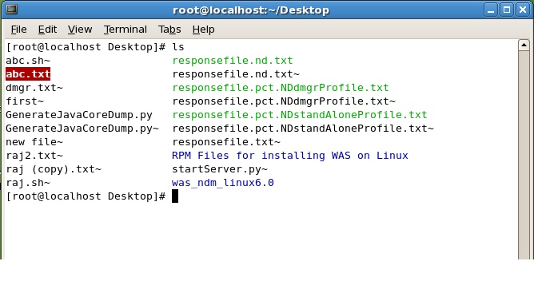
- List all the hidden files in a directory?
Ans : ls –a.
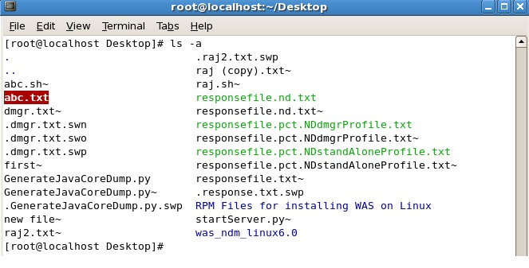
- How to list all the files in ling list format?
Ans : ls –ltr
It gives the files and directories list with permissions,
first character ‘–‘ indicates files, ‘d’ indicates directory.
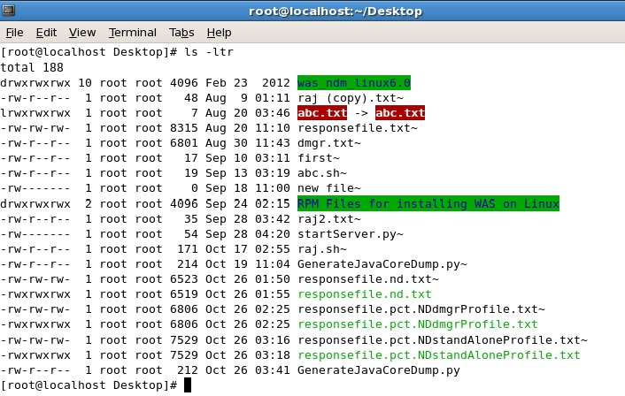
- How to list all the running java processes?
Ans : ps –ef | grep java

- How to list all the listening ports ?
Ans : netstat –a
- How to know the port number based on process id<PID>?
Ans : netstat –antp | grep <pid>

- How to know the processed id <PID> based on port number?
Ans: netstat –antp | grep <port> a: all, n:numeric, t:tcp, p:processID

- How to change the file permissions?
Ans: chmod 777 <filename>
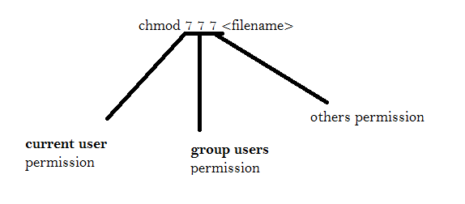
2⁰ = 1 indicates → executable (x)
2¹ ⁼ 2 indicates → write(w)
2² ⁼ 4 indicates → read(r)
3 =1+2 means write and executable
5 =1+4 means executable and read
6 = 4+2 means read and write
7 = 1+2+3 means read write and executable
We can give maximum value as 7. (1–7).

Eg: What indicates chmod 723 f1.txt?
→ User can have the permissions to read, write and execute the file f1.txt.
Group users only have the permission to write the file f1.txt.
Others can have the permissions to read and write the file f1.txt.

- What is the use of sticky bit?
Ans : The owner or Super User only can delete and rename the file, If you enable a sticky bit on a file, group users and Others only can read, write and execute that file but can’t delete
Ex : chmod +t <file name> → To enable the sticky bit.
chmod –t <file name> → To disable the sticky bit.
- Command to go to previous directory?
Ans : cd –

- Command to go to root User directory?
Ans : cd ~
pwd <enter>
o/p: /home/<user name>
- Command to check ip address?
Ans : ifconfig → to find the ipaddress.
- Command to check free disk space?
Ans : df –m /<dir name> → to find the free disk space,(-m for MB ,-k for KB).
free disk space:
MB: (current directory)
df -m .
GB:
df -g .
Used space:
MB: (Current Directory)
du -m .
GB:
du -g .
- Command to find free memory?
Ans: free –m → to find the free memory,(-m for MB ,-k for KB).
Used memory: vmstat (statistics)
- How to change ownership of a file?
Ans: chown <user name>:<group name> <file name>
To change entire directory:
chown -R <username>:<password> <Path of the directory>
- How to find how many users are logged in that unix box?
Ans : users (or) who
- How to find with which user name is logged in?

Ans : whoami , who am i .
- How to find the given OS is 32 bit or 64 bit?
Ans : arch (or) uname –m
- How to find the given os version?

Ans : more /etc/*release

- I want to execute a script, everyday at 5:00pm. Write a crontab syntax to achieve that?
Ans : <min> <Hours> <day of the month> <month> <day of the week> <path of script>
* 17 * * * <path of script>
- How to list the crontabs?
Ans : cronjob – l
- What is the difference between kill –3, kill –9 and kill –15?
Ans: kill –3 <PID> → to generate the “Thread dumps”
kill –9 <PID> → to kill the process forcibly
kill –15 <PID> → it will wait to kill the process until the child processes are killed.
- What is the command to make a tar file?
Ans : tar –cvf <filename>.tar <path of the desired folder>
- Command to extract a tar file?
Ans : tar –xvf <filename>.tar /<directory to extract>
- What is the difference between ‘diff’ and ‘cmp’ commands?
Ans : cmp → it compares two files and gives the output like “Line no. and Byte” which indicates the first difference.
Syn: cmp
diff → it compares two files or directories and gives the output which words are different when comparing the files, which files are different when comparing the directories.
- What is the difference between tail and head commands?
Ans : head → list the top files.
Eg: - head -5 <filename>
tail → list the last files.
Eg: - tail -5 <filename>
- How to add a new user?
Ans : useradd <user name>
- How to change the password?
Ans : passwd <new password>
- How to check the connectivity between two unix boxes?
Ans : ping <ip address>
Eg: ping 192.168.64.128
- What is the difference between find and grep command?
Ans : find → to search the word recursively in a particular file.
Syn: find /<dir-name> -name “<filename>”
Eg: find /root/Desktop -name “abc.txt”
- find . –name “<filename>” → search goes in current directory.
- find / -name “<filename>” → search goes all the directories in file system.
- find ~/ -name “<filename>” → search goes the root directory.
grep → to search the word in a particular file. But it is not recursive.
Syn: grep “<string>” <filename>.
Eg:- grep “rajkumar” /root/Desktop/abc.txt
- How to list running java processes?
Ans : ps –ef | grep java
- How to check Webserver is running or not?
Ans : ps aux | grep httpd (or) ps auxf | grep httpd
- How to run a process in the back ground?
Ans : Put “& “ at the end of the command.
Syn : - <complete command> &
- How to bring the process to fore ground?
Ans : fg <pid>
- What is the default telnet and ssh port numbers?
Ans : 22 → for ssh and 23 → for telnet.
- How to find and replace a string in a file?
Ans : sed – i “s/<old string>/<new string>/g” <file name>
- How to rename a file?
Ans : mv <old file name> <new file name>
Eg : mv /root/Desktop/abc.txt /root/Desktop/rajkumar.txt
- Command to find files which are older than 15 days?
Ans : find <directory path> –atime +15 (–mtime also will work as same)
[syn : find {directory to search in} –atime {+,–, } {number of days}
(+) means greater than, (–) means less than and without anything means exactly equal to.]
Note :
[Three times tracked for each file in Unix are these:
- access time – atime
- change time – ctime
- modify time – mtime

atime – File Access Time
Access time shows the last time the data from a file was accessed – read by one of the Unix processes directly or through commands and scripts.

ctime – File Change Time
ctime also changes when you change file's ownership or access permissions. It will also naturally highlight the last time file had its contents updated.

mtime – File Modify Time
Last modification time shows time of the last change to file's contents. It does not change with owner or permission changes, and is therefore used for tracking the actual changes to data of the file itself.
- Command to find recent modified files?
Ans : ls –lrt
- What is the use of umask and what is the default umask value?
Ans : The umask specifies the permissions you do not want given by default to newly created files and directories.
To reset the values. Default umask value is 022.
- How to set umask ?
Ans : umask 022
- How to mount a file system?
Ans : mount <file system name> <where to mount>
Eg: mount /dev/cdrom /mnt/cdrom
Mount: A file system can be "mounted" on your Linux system interactively or automatically at startup. Then the file system is just as accessible as any other file system on your computer. The command to "attach" a file or directory ismount, and the command to "detach" a mounted file or directory is umount (see UNIX man (manual) pages for the commands mount and umount for more information). Users should detach from the file system when the resource is no longer needed.
- Command to find top 8 processes which consumes high cpu utilization?
Ans : ps auxf | sort –nr –k 3| head –8
- Command to find top 8 files which consumes high disk usage?
Ans : du –sm *|sort –nr | head –8
Here ‘s’ summarizes all the reports, ‘m’ indicates size in MB.
- What is the command to find the files size more than 100 MB?
Ans : find . –size +100M
find /<dirname> –size +100M
Note : ‘.’ Indicates current directory.
Eg : find . –size +100M
- What is the use of lsof command?
Ans : lsof stands for list the open files, which will list all the open files in the system. The open files include network connection, devices and directories.
Syn : lsof | more
- more → it is used to display or read a file page by page. For next page press enter.
Syn : more <file name>
- What is the difference between softlink and hardlink?
Ans : Softlink → It create a separate inode for linked file. We should not delete the original file to access the softlink.
hardlink → It doesn’t have a separate inode. Hard link file will be deleted when we delete the original file.
- Command to list the processes which are currently running?
Ans : netstat –antp
- What are different run levels in Linux?
Ans :-
Run Level 0: Halt System (To shutdown the system)
Run Level 1: Single user mode
Run Level 2: Basic multi user mode without NFS
Run Level 3: Full multi user mode (text based)
Run Level 4: unused
Run Level 5: Multi user mode with Graphical User Interface
Run Level 6: Reboot System

- Command to fine HOSTNAME of system?
Ans: hostname

- Command to display number of lines in a file?

Ans: - wc -l <filemname> → it gives no of lines in a file.
wc -m <filename> → it gives no of characters in a file.
wc -w <filename> → it gives no of words in a file.
wc <file name> → it gives no of lines ,no of words, no of bytes in given file.
- Command to list number of files in a directory?
Ans: - ls -1 /root/Desktop/RPM | wc -l
- How to set java path in Linux/Unix?
Ans : - Setting java path(In Temporary way)

JAVA_HOME=/usr/lib/jvm/jre-1.6.0-openjdk
export $JAVA_HOME

Setting java path (In Permanent way)
Edit ~/ .bashrc and place below two lines in that file and save the file.
Vi ~/.bashrc
JAVA_HOME = /usr/lib/jvm/jre-1.6.0 -openjdk
export $JAVA_HOME

Note :- Please note that the file ~/.bashrc is similar, with the exception that ~/.bash_profile runs only for Bash login shells and .bashrc runs for every new Bash shell.

VI-EDITOR Commands:

j → move cursor to one line down
k →move cursor to one line up
h →move cursor left to one character
l → move cursor right to one character
0(zero) → move the cursor to staring of current line
$ → move cursor to end of end of current line
w → move cursor to beginning of next word
b → move cursor to beginning of previous word
u → undo

G → move cursor to end of the File
1G → move cursor the starting of the file
3G → move cursor to the 3rd line of the file. (nG → for n^{th} line).

dd → delete entire line from current cursor position, without blank line.
cc → deletes entire line from current cursor position with auto edit of blank line.
D → Deletes the right side portion of the cursor position.

o (small oh) → to insert a blank line below the cursor (current line).
O(capital oh) → to insert a blank line above the cursor (current line).

i → to edit.
:q → after saving only it will quit otherwise it won’t quit from editor.
:q! → quit without save.
:wq → save and quit.

- Ho to set line numbers in vi editor?
Ans : press esc → :set nu press enter.

- How to delete blank lines in a file?
Ans : - vi <filename>
Press esc → : g/^$/d → press enter

- How to delete 50 lines from a file?
Ans : vi <filename>
Press esc → 50D
Deletes 50 lines from current cursor position.

- How to delete 50th Line form a file?
Ans: sed '50d' <fileName.txt>

